|  |  |
| --- | --- |
| school-learn-study-hat-graduate-512.png | ***Study*** |

Read session 11.1, 11.2, 11.3, 11.4, 11.5, 11.6, 11.8, 11.9, 11.12 of the following book:

<http://www.ict.ru.ac.za/Resources/cspw/thinkcspy3/thinkcspy3.pdf>

And then answer the following questions:

* What is nested list?

Nested list là list mà phần tử của list ấy lại là 1 list khác, hay còn gọi là list lồng trong list, tương tự với mảng nhiều chiều của C

* Can a list store both integers and strings in it?

Có, list có thể lưu trữ đồng thời cả str và int

* Do exercise 1, 2 in this chapter (note: these include sub-exercises, so you better start early)

Ex1:

>>> list(range(10,0,-2))

[10, 8, 6, 4, 2]

Nếu start item > stop item và step <0 thì hàm range sẽ giảm start item xuống, mỗi lần tăng theo giá trị của bước nhảy cho đến khi giá trị chạy > stop item thì dừng lại.

Rule của 3 thành phần này: start +step>stop

Như ví dụ sau:

>>> list(range(10,0,2))

Thì vì start+step =10+2>0 do đó list trả về là rỗng []

Ex 2

import turtle

tess = turtle.Turtle()

alex = tess

alex.color("hotink")

Trong đoạn code này alex được assign bằng tess, do đó thực chất python chỉ tạo ra 1 object turtle mà thôi, cả 2 variable đều trỏ đến (reference) đến object này. Khi kiểm tra id hoặc alex is tess thì trả về kết quả true. Vì vậy khi biến alex set color thành pink thì tức là object turtle được trỏ đến có thuộc tính màu là hotpink, và tess cũng biến đổi màu thành hotpink

>>> alex is tess

True

>>> id(alex)

2451516460056

>>> id(tess)

2451516460056

|  |  |
| --- | --- |
| http://www.bestappsforkids.com/wp-content/uploads/2012/04/save-turtle.png | ***Turtle exercises*** |

Given the following list: colors = ['red', 'blue', 'brown', 'yellow', 'grey']

Using turtle to draw the following shapes:

|  |  |
| --- | --- |
|  | 2. |
|  |  |

Hint:

Google:

“turtle stroke color”

“turtle fill color”

|  |  |
| --- | --- |
| 6iporAnbT.jpg | ***Serious exercises*** |

1. Finish CRUD exercise in class, simulate a clothes shop

Welcome to our shop, what do you want (C, R, U, D)? C

Enter new ===item: Jeans

Our items: T-Shirt, Sweater, Jeans

Welcome to our shop, what do you want (C, R, U, D)? R

Our items: T-Shirt, Sweater, Jeans

Welcome to our shop, what do you want (C, R, U, D)? U

Update position? 1

New item? Skirt

Our items: T-Shirt, Skirt, Jeans

Welcome to our shop, what do you want (C, R, U, D)? D

Delete position? 2

Our items: T-Shirt, Skirt, Jeans

Handle the exceptions (upper, lower case, index out of range) yourself

1. You are a shepherd who owns a flock of sheep

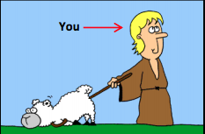

Each of your sheep of your flock has different size:



2.1 Create a list to represent the sizes of your flock, using list, and print all of your flock size, expected screen output:

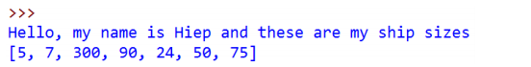

2.2. At the end of each month, you have to choose one and only one sheep to shear and thus you want to choose the biggest one to maximize your profit. Write a program to search for the biggest sheep in your list:

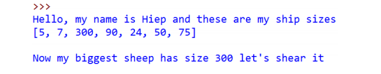

2.3. When your biggest sheer, its size will return to the default size, which is 8.

Print out your ship size after shearing the biggest one:

Hint: Google “Python List index function”

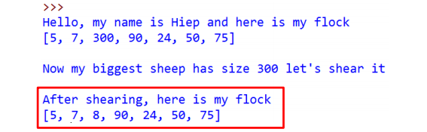

2.4 In the following month, EVERY sheep in your flock grow, they have their size increased by 50. Print them out

Hint: Ask TA if you need help

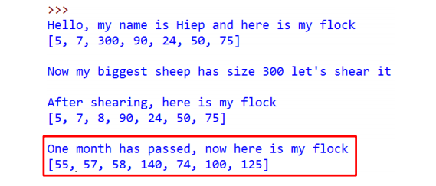

2.5. Let do this for 4 months (or as long as you want):

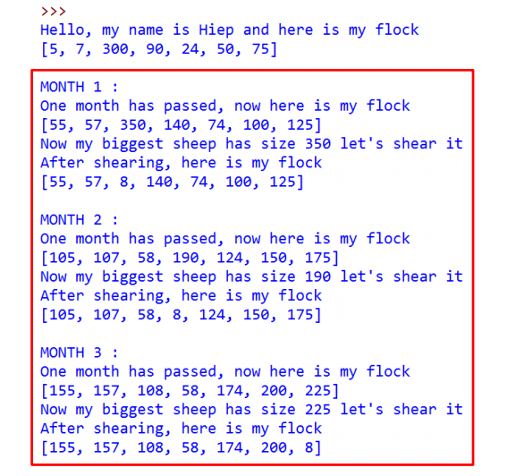

2.6 After day by day shearing shapes, you became bored. You want to sell your flock to travel the world. In order to have fair trade, you must now calculate the total size of your sheep and then the expected money you can get from your flock before going to the market. Write a program to calculate the total size of your sheep as well as the money you would have. Expected screen output:

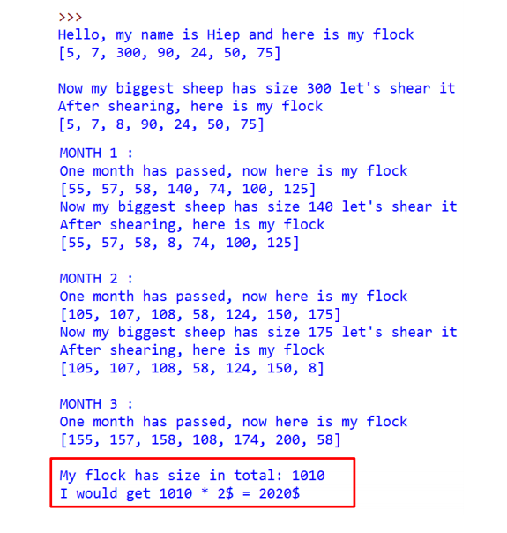

|  |  |
| --- | --- |
| system_config_boot.png | ***Tools preparation*** |

Learn how to upload file to github.com by learning the following steps:

* Clone your repository
* Submit your files
* Push you files

Video tutorial: <https://www.youtube.com/watch?v=Yq32Ifx0bXw>

From now on, using git to commit your homework is a MUST, no more .zip, Google Drive, DropBox …